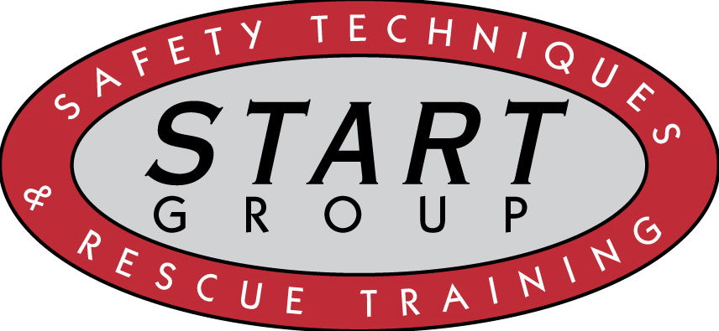 | Administrative  Table of Contents

Policies

A-1 Uniforms and Personal Protective Equipment A-2 Payroll and Insurance
A-3 Equipment Inspection and Maintenance
A-4 Certifications and Training Documentation
A-5 Paperwork and HIPPA
A-6 Near Miss and Injury Reporting
A-7 Sexual Harassment
A-8 Substance Abuse
A-9 Training Requirements

